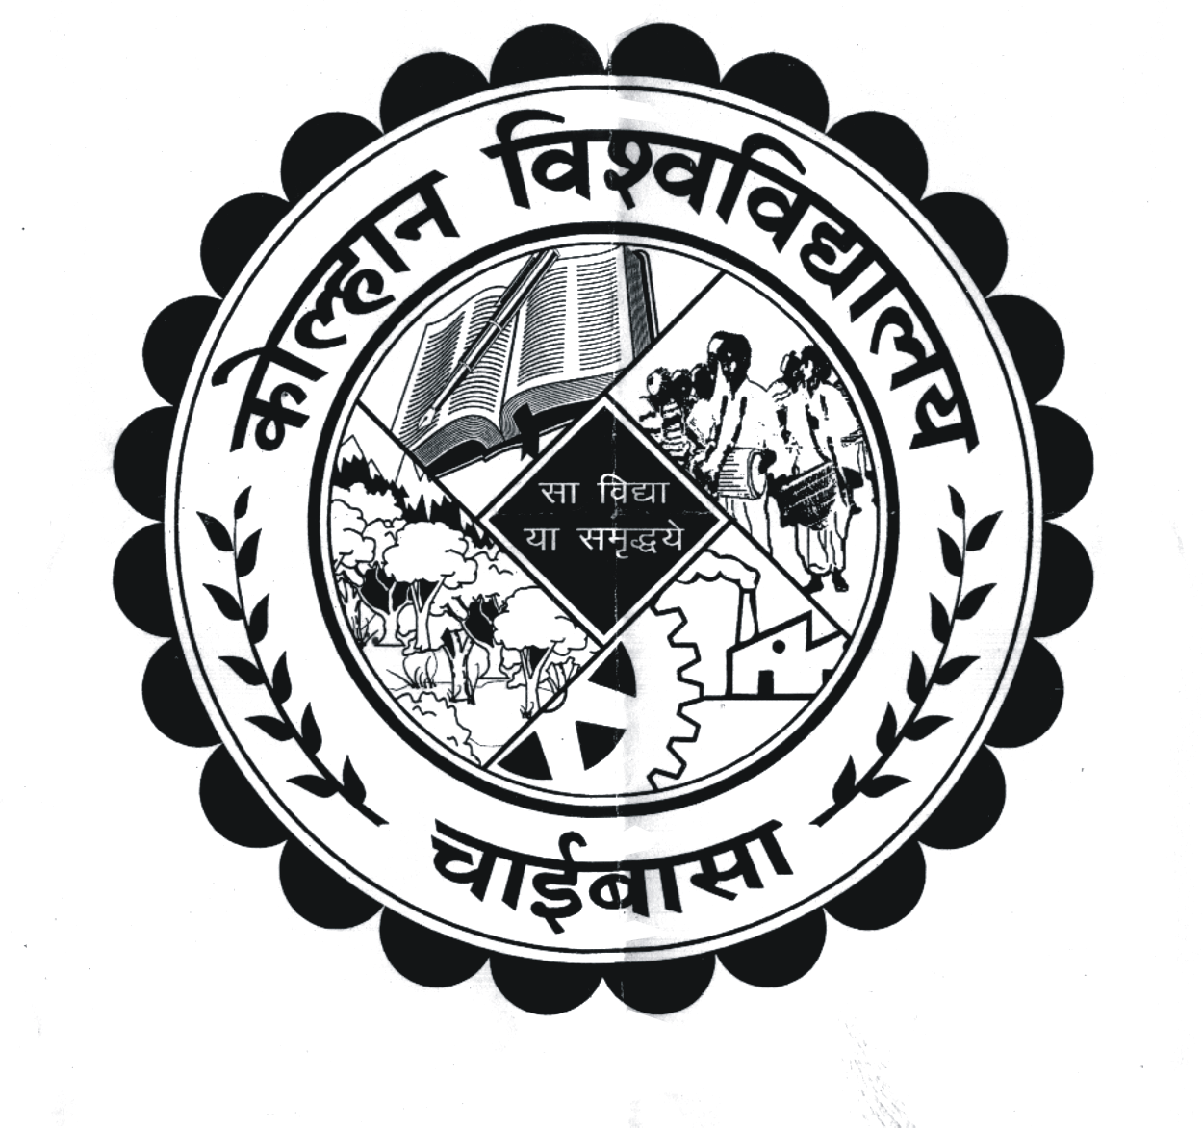
KOLHAN UNIVERSITY, CHAIBASA
(EXAMINATION DEPARTMENT

(A). Revised Programme of BDS 3rd Year (2014-18) & 4th Year (2013-17) of (I) Annual Exam, 2017.

Exam Time: - 10. A.M. to 1. P.M.

Reporting Time: - 9.30 A.M.

Date& Days | Paper | BDS 4th Year  (2013-2017) | Paper | BDS 3rd Year  (2014-2018)
 |  | Subject |  | Subject
10/08/2017 (Thursday) | I | Public Health Dentistry | --- | ---
11/08/2017 (Friday) | --- | --- | I | General Medicine
12/08/2017 (Saturday) | II | Periodontology | --- | ---
16/08/2017 (Wednesday) | --- | --- | II | General Surgery
17/08/2017 (Thursday) | III | Orthodontics & Dentofacial Orthopaedics | --- | ---
18/08/2017 (Friday) | --- | --- | III | Oral Patho. & Oral Microbiology
19/08/2017 (Saturday) | IV | Oral Medicine & Radiology | --- | ---
21/08/2017 (Monday) | V | Oral & Maxillofacial Surgery | --- | ---
23/08/2017 (Wednesday) | VI | Conservative & Endodontics | --- | ---
25/08/2017 (Friday) | VII | Prosthodontics & Crown & Bridge | --- | ---
28/08/2017 (Monday) | VIII | Pediatrics & Preventive Dentistry | --- | ---

(B). Centre of Examination
Name of the College | Name of Centre | Name of the centre Supdt.
Awadh Dental College, Jamshedpur | Karim City College, Jamshedpur. | Principal,  Karim City College, Jamshedpur.

- Provision of the conduct of examination Act.1981 and directive of the Hon’ble High Court, Patna dated 22.12.1995 will be strictly implemented for fair conduct of Exam.
- In case of stay out/ walkout /mass scale of unfairmeans, there will be no re-examination and Zero marks will be awarded.
- In case of misprint regarding examination programme in the newspaper, the University is not likely to be responsible and no re-examination will be held. The examinees concerned are therefore directed to verify the examination programme from their respective college.
- In case of gross indiscipline by the examinees (Assault to invigilators or any person, tearing of answer books, forcible prevention of other examinees from appearing at the examination and damage to property etc.) they will make themselves liable to be debarred from examination may also lead to their rustication.

By order of the Vice-Chancellor

Sd/-
(Dr. P.K. Pani)
Controller of Examinations
Kolhan University, Chaibasa

Memo No. NC/KU/CE/10418-10422/17 Dated:22/07 /2017

Copy to:
1. The Principal of the College concerned.
2. The Centre Supdt. Concerned.
3. The Finance Officer, K.U., Chaibasa for information & needful.
4. Office of the VC/PVC/R for information to VC/PVC/Registrar

5. The Editor- (a). Prabhat Khaber, New Jain Market, Chaibasa
(b). Dainik Jagaran, Chaibasa, (c). Hindustan, Chaibasa
(d). New Ispat Mail, Chaibasa, (e). Dainik Bhaskar
(f). The Hindustan Times, (g). The Telegraph
(h). Chamakta Aina, Chaibasa, (i). Uditvani, Chaibasa
(j). Jharkhand News Line, Chaibasa, (k). Farooqui Tanzeeb
for favour of publication in their respective daily, free of cost, if desired.

Controller of Examinations
Kolhan University, Chaibasa

